
Tribhuvan University
Faculty of Humanities and Social Sciences
Smart College Suite

A PROJECT REPORT

Submitted to
Department of Computer Application
G.P. Koirala Memorial College
Sifal, Kathmandu

In partial fulfillment of the requirements for the Bachelor’s in Computer Application

Submitted by

Prerana Koirala
6-2-703-13-2020
Biplov Karki
6-2-703-6-2020
December, 2024

Under the Supervision of
Shiva Raj Pandey

Tribhuvan University
Faculty of Humanities and Social Sciences
G.P. Koirala Memorial College
Sifal, Kathmandu
Bachelor of Computer Applications (BCA)

SUPERVISOR’S RECOMMENDATION

I hereby recommend that this project prepared under my supervision by PRERANA KOIRALA and BIPLOV KARKI entitled “SMART COLLEGE SUITE” in the Partial Fulfillment of requirement for the degree of Bachelor’s in Computer Application is recommended for that final evaluation.

…………………………….
Mr. Shiva Raj Pandey
Supervisor/Faculty Member
Department of Information Technology
G.P. Koirala Memorial College

Tribhuvan University
Faculty of Humanities and Social Sciences
G.P. Koirala Memorial College

LETTER OF APPROVAL

This is to certify that this project prepared by PRERANA KOIRALA entitled “PUBLIC TRANSPORTATION SYSTEM” in partial fulfillment of the requirements for the degree of Bachelor of Computer Application has been well studied. In our opinion it is satisfactory in scope and quality as a project for the required degree.

……………………………………  Shiva Raj Pandey  Supervisor  GPKMC | …………………………………………..  [External Examiner]  Academic Designation  FOHSS, Tribhuvan University
……………………………………  Sujan Shrestha  Program Coordinator  GPKMC | …………………………………………..  Shiva Adhikari  Campus Chief

ABSTRACT
Efficient public transportation systems are essential for enhancing urban mobility and sustainability. This project presents a Public Transportation System designed to improve user experience in navigating and utilizing public transit within the Kathmandu Valley. The system allows users to view available routes and their detailed information, including stops along the selected route. Additionally, users can identify nearby stops based on their location, select a destination, and calculate the fare for their journey. The system features data-saving capabilities that enable users to generate personalized travel reports, providing insights such as the total distance traveled and cumulative travel expenses. By integrating route visualization, fare calculation, and reporting functionalities, this system aims to empower users to make informed travel decisions, enhance route planning, and contribute to a more organized and user-centric public transportation experience.
Keywords: public transportation; route planning; fare calculation; travel reports; urban mobility; Kathmandu Valley

ACKNOWLEDGEMENT
We would like to express our special thanks of gratitude to our supervisor Mr. Shiva Raj Pandey who gave us the golden opportunity to do this wonderful project on the topic of Public Transportation System (PTS), which also helped us in doing a lot of research and we came to know about so many new tools and technologies.
We would like to express our special thanks of gratitude to our Campus Chief Mr. Shiva Adhikari who gave us permission to do this Project.
I would like to express my special gratitude and thanks to our BCA Program Coordinator Mr. Sujan Shrestha for his support and help for our personnel development and mainly for the completion of this Project.
I am highly indebted to GP Koirala Memorial College for their guidance and constant supervision as well as for providing necessary information regarding the Project and support in the completion.
We would also like to express my gratitude towards library and member of GP Koirala Memorial College for their kind co-operation and encouragement which help me in completion of this Project.
We would also like to thank our parents and friends who helped us a lot in finalizing this project within the limited time frame.
In the end, we would also like to thank Tribhuvan University for giving us this opportunity via the course of Computer Application to help us understand the project ethics at this early stage and helped us to evaluate my knowledge and expand it a little more.

Prerana Koirala
Roll No: 70302014
Date: 2081/08/22

TABLE OF CONTENTS

SUPERVISOR’S RECOMMENDATION ii
LETTER OF APPROVAL iii
ABSTRACT iv
ACKNOWLEDGEMENT v
LIST OF ABBREVIATIONS viii
LIST OF FIGURES ix
LIST OF TABLES x
CHAPTER 1: INTRODUCTION 1
1.1 Introduction 1
1.2 Problem Statement 1
1.3 Objectives 2
1.4 Scope and Limitation 2
1.4.1 Scope 2
1.4.2 Limitations 2
1.5 Report Organization 3
CHAPTER 2: BACKGROUND STUDY AND LITERATURE REVIEW 4
2.1 Background Study 4
2.2 Literature Review 4
CHAPTER 3: SYSTEM ANALYSIS AND DESIGN 7
3.1 System Analysis 7
3.1.1 Requirement Analysis 7
3.1.2 Feasibility Analysis 9
3.1.3 Data Modeling (ER-Diagram) 12
3.1.4 Process Modeling (DFD) 13
3.2. System Design 14
3.2.1. Architectural Design 14
3.2.2 System Flowchart 15
3.2.3. Interface Design (UI Interface) 18
3.2.2 Physical DFD 20
3.3 Algorithm analysis 22
CHAPTER 4: IMPLEMENTATION AND TESTING 24
4.1. Implementation 24
4.1.1 Tools Used 24
4.1.2 Implementation Details of Modules 25
4.2. Testing 28
4.2.1. Test Cases for Unit Testing 28
4.2.2. Test Cases for System Testing 31
CHAPTER 5: CONCLUSION AND FUTURE RECOMMENDATIONS 34
5.1. Lesson Learnt / Outcome 34
5.2. Conclusion 34
5.3. Future Recommendations 35
REFERENCES
APPENDIX I

LIST OF ABBREVIATIONS
API: Application Programming Interface
BCA: Bachelor of Computer Applications
BRT: Bus Rapid Transit
CRUD: Create, Read, Update, and Delete
CSS: Cascading Style Sheet
DFD: Data Flow Diagram
ERD: Entity Relationship Diagram
GIS: Geographic Information Systems
GPS: Global Positioning System
JS: JavaScript
KSUTP: Kathmandu Sustainable Urban Transport Project
MERN: MongoDB, Express.js, React.js, and Node.js
MS Office: Microsoft Office
OTP: One-Time Password
PTS: Public Transportation System
UI: User Interface
VS Code: Visual Studio Code

LIST OF FIGURES
Figure 3.1: Agile Methodology for Public Transportation System 7
Figure 3.2: Use Case Diagram of Public Transportation System 9
Figure 3.3: Gantt chart for Public Transportation System 11
Figure 3.4: Entity Relational Diagram for Public Transportation System 12
Figure 3.5: level 0 DFD for Public Transportation System 13
Figure 3.6: Level 1 DFD for Public Transportation System 14
Figure 3.7: Architectural Design of Public Transportation System 15
Figure 3.8: Flow chart of Public Transportation System for Admin 16
Figure 3.9: Flow chart of Public Transportation System for Users 17
Figure 3.10: UI Home page of Public Transportation System 18
Figure 3.11: Register page of Public Transportation System 19
Figure 3.12: Login page of Public Transportation System 20
Figure 3.13: Physical DFD of Public Transportation System for Users 21
Figure 3.14: Physical DFD of Public Transportation System for Admin 21

LIST OF TABLES
Table 3.1: Gantt chart Table for Public Transportation System 11
Table 4.1: Test case for User Registration of Public Transportation System…………….29
Table 4.2: Test case for User Login of Public Transportation System. 30
Table 4.3: Test Case for nearest route Success of Public Transportation System 31
Table 4.4: Test Case for Calculating fare of Public Transportation System 32
Table 4.5: Add stop of Public Transportation System 32
Table 4.6: Routes add form of Public Transportation System 32
Table 4.7: Travel approval form of Public Transportation System 33

CHAPTER 1: INTRODUCTION

Introduction
The public transportation in Kathmandu Valley serves as a critical lifeline for thousands of commuters daily. However, inefficiencies such as disorganized bus routes, limited access to reliable information, and the absence of journey-planning tools create significant challenges for passengers. These issues not only inconvenience users but also contribute to traffic congestion, increased travel time, and environmental concerns due to higher emissions from prolonged vehicular idling and inefficient routing.
This project seeks to address these challenges by introducing a modern, web-based platform designed to revolutionize the public transportation experience. Leveraging the MERN stack and a responsive interface styled with Tailwind CSS, the platform empowers users to seamlessly explore routes, locate nearby bus stops, calculate fares, and plan their journeys. It features real-time updates on bus locations and estimated arrival times, ensuring that passengers can make informed decisions about their commutes. Additionally, the system provides robust administrative tools to streamline the management of routes, schedules, and bus stops.
By adopting a user-centric and structured approach, this project aims to modernize Kathmandu Valley's public transportation network. It emphasizes accessibility and efficiency, helping commuters save time and minimize travel-related frustrations. Furthermore, by encouraging more organized and predictable transit operations, the platform promotes sustainable urban mobility, reduces congestion, and supports eco-friendly transportation practices. This initiative paves the way for a smarter and more connected urban transport ecosystem, benefitting both passengers and administrators while contributing to a greener future for the region.

Problem Statement
Public transportation in Kathmandu Valley serves as a critical mode of travel for residents, yet it is hindered by several inefficiencies. The lack of organized bus routes, absence of reliable route information, and difficulties in locating nearby bus stops make commuting inconvenient and time-consuming for passengers. Additionally, the absence of a streamlined system for fare calculation and travel planning further complicates the process.
For commuters, these issues lead to frustration, delays, and inefficient travel experiences. On the administrative side, managing bus routes, schedules, and stops remains a challenge due to the lack of a centralized and user-friendly platform
These inefficiencies not only affect the daily lives of passengers but also contribute to increased traffic congestion and reduced reliance on public transportation, which is vital for sustainable urban development. Without a structured system to address these challenges, public transportation in Kathmandu Valley risks becoming less accessible and reliable for its users. This project seeks to address these problems by developing a web-based platform that simplifies route planning, enhances user experience, and supports better management of transportation resources.

Objectives
The system addresses the current challenges faced by commuters. Its key objectives are:
- To create a web-based platform for efficient route searches, nearby stop detection, and fare calculation in Kathmandu Valley.
- To simplify the management of routes, schedules, and stops, improving the organization of public transportation.

Scope and Limitation

Scope
This project focuses on developing a web-based platform for public transport, with the following key features:
- Users can search for bus routes, locate the nearest bus stops, and calculate fares based on the route and destination.
- Administrators can manage bus routes, schedules, and bus stop information through an admin interface.
- The platform features an intuitive interface, developed with Next.js and styled using Tailwind CSS, for a smooth user experience.
- The system improves accessibility, reliability, and convenience for passengers using public transportation.

Limitations
While the system provides essential features, it does have certain limitations:
- The platform does not include real-time tracking of buses or live updates on bus locations.
- GPS data may be inaccurate in areas with poor satellite reception.
- The system relies on accurate and timely data input, which can be prone to human error.

Report Organization
Introduction
This chapter deals with the introduction of the system with its objectives and limitations along with the reason why the system is made.

Background Study and Literature Review
This chapter summarizes the work that has been carried out in the field of data mining and also describes the features about some existing applications related to the Public Transportation System.

System Analysis and Design
This chapter focuses on the different requirement of the system, which describes about the functional, non-functional, feasibility analysis, Entity Relational diagram, Data Flow Diagram, design of the system with system architecture, database schema, and interface design.

Implementation and Testing
This chapter emphasizes tools used in system development, implementing details and result of test performed.

Conclusion and Future Recommendation
This chapter highlights brief summary of lesson learnt, outcome and conclusion of the whole project and explain what have been done and what further improvements could be done.

CHAPTER 2: BACKGROUND STUDY AND LITERATURE REVIEW

Background Study
Public transportation in Nepal, particularly buses in the Kathmandu Valley, is essential for urban mobility, but it struggles to meet the growing demand due to rapid urbanization, economic development, and increasing private vehicle ownership [1]. The bus network, primarily operated by private entities, faces overcrowding, delays, and poor maintenance, compounded by inadequate infrastructure such as bus terminals, poor roads, and lack of integration between transport modes [2][3]. Additionally, buses often operate without a clear timetable, leading to irregular service and chaos due to a lack of fare systems and safety regulation [4][5].

To address these issues, the Kathmandu Sustainable Urban Transport Project (KSTUP), supported by the Asian Development Bank, focuses on improving infrastructure and introducing Bus Rapid Transit (BRT) corridors to ease traffic congestion and improve bus operations [6]. Efforts are also being made to modernize the fleet with electric buses and introduce GPS tracking, smart ticketing, and real-time data collection to enhance service quality [11].

However, challenges remain, including political interference, lack of public awareness, and coordination issues among stakeholders. Overcoming these challenges requires ongoing investment, improved infrastructure, and public-private partnerships [12]. In conclusion, while there are efforts to modernize Nepal's bus system, the success of these initiatives hinges on effective governance and stakeholder cooperation.

Literature Review
The public transportation system in Nepal, particularly buses within the Kathmandu Valley, serves as the primary mode of urban mobility. However, it faces inefficiencies, a lack of modernization, and significant infrastructural challenges. This literature review examines the current state of the bus transportation system, the challenges it faces, the technological advancements being proposed, and sustainable practices being integrated into the system.

Buses dominate Nepal's public transportation network, meeting the mobility needs of a growing urban population. Paudyal et al. highlight that bus services are primarily operated by private entities with minimal government regulation over routes, schedules, and fare systems, leading to issues like competition among operators and lack of service standardization [1].

The system faces numerous challenges. One of the major issues is infrastructural deficiencies, such as poorly maintained roads, traffic congestion, and the absence of dedicated bus lanes, which reduce the efficiency of bus services. Thapa and Dahal (2020) emphasize the need for urgent infrastructure improvements to facilitate better bus operations [2]. Operational inefficiencies like overcrowding, irregular schedules, and outdated vehicles further hamper the system. Adhikari (2021) notes that these inefficiencies discourage commuters from relying on public transportation [3]. Moreover, environmental concerns arise from the extensive use of diesel-powered buses, which significantly contribute to air pollution in the Kathmandu Valley. Gurung (2019) reports that the use of fossil fuels in public transport is a major factor in the region’s deteriorating air quality [4].

The Kathmandu Sustainable Urban Transport Project (KSUTP) was launched to modernize the public transportation system, focusing on sustainability and improving urban mobility. The project involves the introduction of larger, eco-friendly buses to replace outdated, inefficient vehicles [5] and the construction of dedicated bus lanes, modern bus stops, and terminals to improve efficiency and convenience [6]. However, challenges such as land acquisition, resistance from transport operators, and delays in funding have hindered the full implementation of the project [7].

Technological advancements are being introduced to enhance the bus system’s efficiency and reliability. GPS tracking systems, for instance, could provide real-time tracking of buses, improving service reliability and commuter satisfaction. Sharma (2022) discusses how GPS-based systems can optimize urban public transport [8]. Additionally, smart ticketing solutions, such as automated fare collection and digital payment systems, can address fare management inefficiencies and reduce cash handling [9].

Sustainability initiatives are also gaining attention in Nepal’s bus transportation system. The adoption of electric buses is one such initiative. Lamsal (2020) advocates for the use of electric buses to reduce emissions and operational costs, though challenges like insufficient charging infrastructure and high initial costs remain [10]. Furthermore, policy frameworks that support private-public partnerships and provide incentives for green vehicles are essential to promoting sustainable urban transport [11].

Neighboring countries, like India, have implemented Bus Rapid Transit (BRT) systems with dedicated bus lanes and centralized management. Mishra (2021) suggests that similar models could be adopted in Nepal to improve the efficiency and reliability of public transportation [12].

In conclusion, the bus transportation system in the Kathmandu Valley faces significant challenges such as infrastructural deficiencies, operational inefficiencies, and environmental concerns. Projects like KSUTP, along with technological advancements and sustainability initiatives, present promising solutions to these challenges. However, successful implementation will require policy support, stakeholder collaboration, and long-term investment.

CHAPTER 3: SYSTEM ANALYSIS AND DESIGN

System Analysis
The Public Transportation System was developed using the Agile methodology, ensuring iterative and flexible progress. The process began with requirement analysis, where functional and non-functional requirements were identified. Based on these requirements, the system design was created, followed by development in iterative cycles (sprints), focusing on implementing key features step by step.
Each sprint included testing to identify and resolve issues early, ensuring the functionality of the system. After implementing all the core features, the system underwent integration and final testing. Any issues found were resolved, ensuring the system was fully functional and ready for deployment.
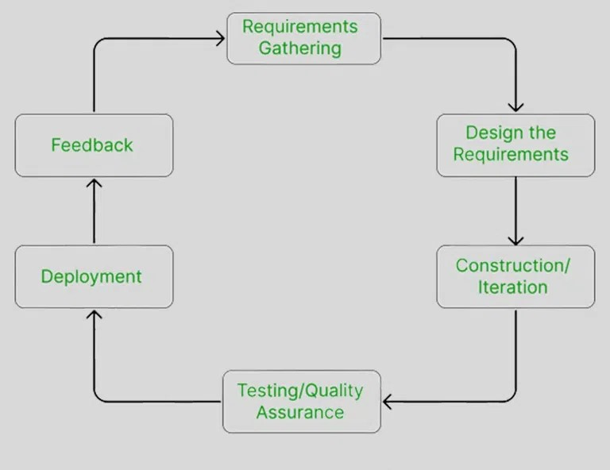
Figure 3.1: Agile Methodology for Public Transportation System

Requirement Analysis
The requirements of the system were collected before starting the development life cycle. Both functional and non-functional requirements were studied to design and develop the Public Transportation System.
- Functional Requirements
For Administration:
- The system should allow the admin to view key details such as total bus routes, total users, total bus stops, and fare structures.
- The admin should be able to manage bus stops, routes, fare structures, and user accounts.
For Registered Users:
- Users should be able to search for routes and view available bus stops.
- The system should display users’ travel history, including previously calculated fares and routes.

USE CASE DIAGRAM
The Public Transportation System is divided into two primary sectors: Admin and Users, each with distinct roles and functionalities:
- Admin: Admins can log in to the system to manage routes, bus stops, fares, and services. They can also generate reports, view bus stops routes and maintain the system. Admins have full control over the system's operation and can log out after completing their tasks.
- Users: Registered users can log in to view the nearest routes, check fare details, and generate fare calculation reports based on selected routes and stops. They can also view the status of their previous fare calculations or reports.
This structure ensures a clear distinction between admin responsibilities and user functionalities, allowing for efficient management and ease of access.
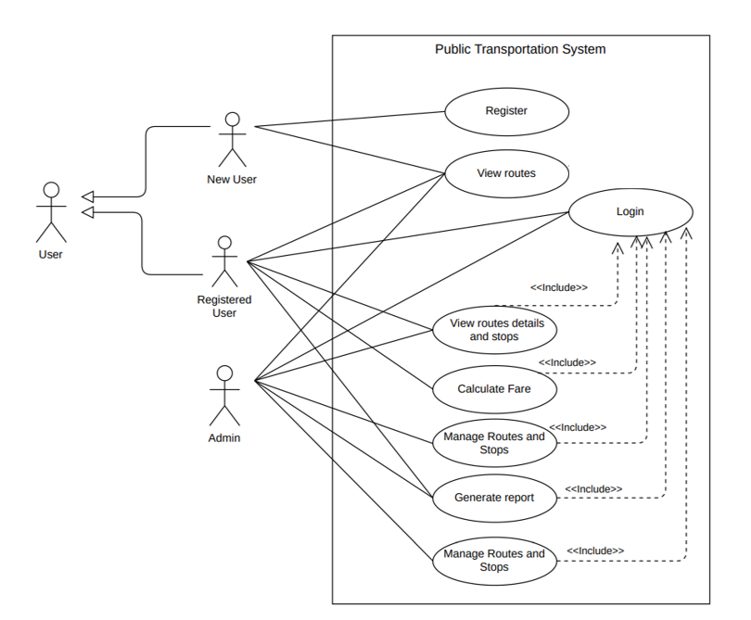
Figure 3.2: Use Case Diagram of Public Transportation System
- Non-Functional Requirement
Different non-functional requirement have been studied and identified and are listed as below:
- Security: The system ensures data security by securely storing user information and employing encryption techniques for passwords.
- Usability and User Experience: The system offers an intuitive and user-friendly interface, ensuring ease of use for both registered users and administrators.
- Performance: The system delivers fast and accurate performance due to the use of a normalized database structure, ensuring quick data retrieval and efficient operations.
- Response Time: The system provides quick response times for all user interactions, ensuring a seamless experience when searching routes, viewing stops, or calculating fares.
- Scalability: The system is designed to scale effectively, accommodating future growth in terms of users, routes, bus stops, and fare structures without compromising performance.

Feasibility Analysis
The feasibility study concluded that the project is able to be implemented to success as it was carefully planned.
      - Technical Feasibility Study
For this project, all the required hardware and software resources were available and capable of handling the project’s needs. The development was done using Visual Studio Code as the primary IDE, with MongoDB for data storage, and Postman for testing and interacting with the API. These tools were sufficient for building and testing the system, allowing for smooth development throughout the process. Given the simplicity of the project, it was easily completed with the limited number of technical resources available.

      - Operational Feasibility Study
Our system is designed with operational feasibility at its core, ensuring a smooth user experience. The interface is intuitive and user-friendly, allowing users with basic computer and internet skills to easily navigate the system. This minimizes the need for extensive training. By incorporating essential features that cater to the needs of our target users, we ensure that the system is both practical and useful. The focus on usability and accessibility guarantees that the system will integrate seamlessly into the users' workflow, providing a functional solution for everyday use.

      - Economic Feasibility Study
From an economic standpoint, our system demonstrates high feasibility. By strategically utilizing open-source resources and tools, we have significantly minimized costs while ensuring optimal performance. The project’s cost-effectiveness continues beyond development, as the system's deployment does not require additional hardware or software investments. Leveraging existing assets allows us to achieve our objectives without straining financial resources. This approach aligns with our commitment to delivering value while maintaining economic sustainability, ensuring that the system remains affordable and efficient throughout its lifecycle.
      - Schedule Feasibility Study
The system is completed within scheduled time and do not exceed the scheduled time.

Table 3.1: Gantt chart Table for Public Transportation System
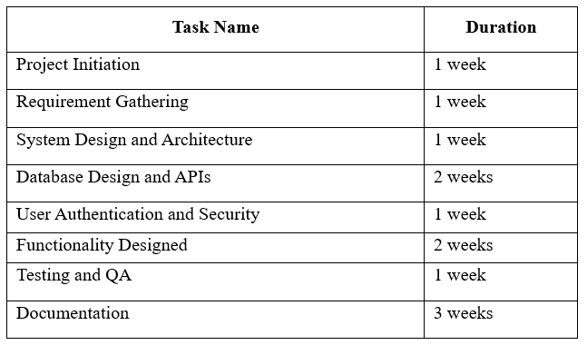

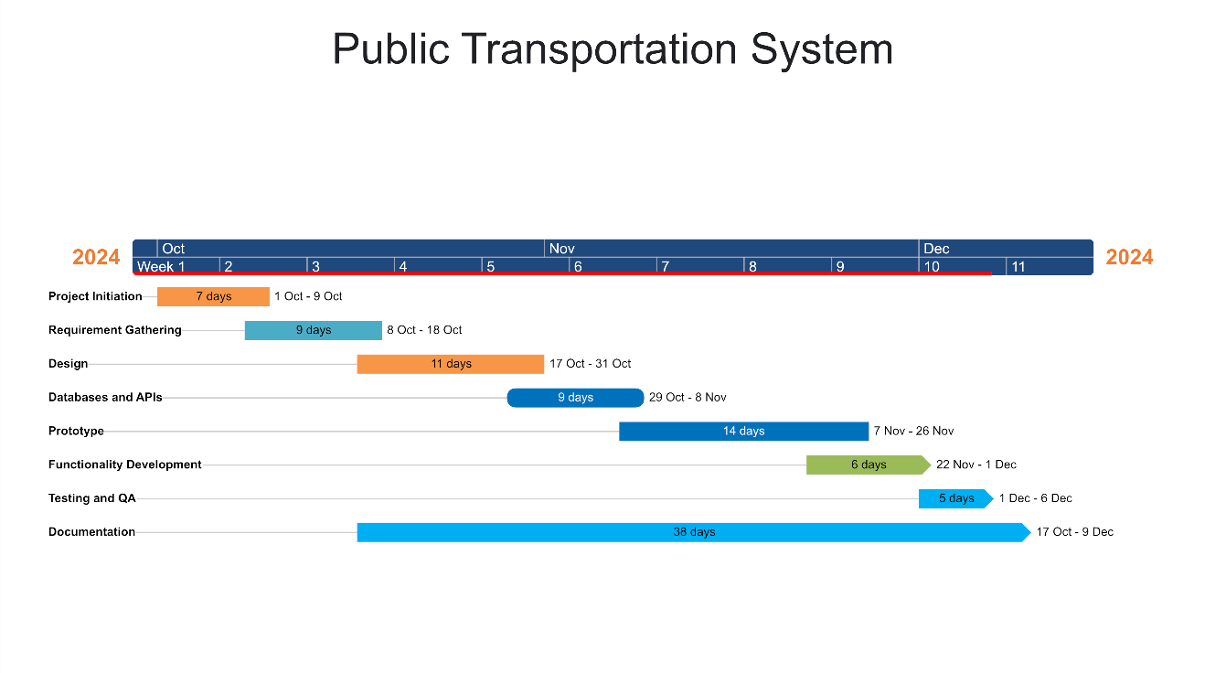
Figure 3.3: Gantt chart for Public Transportation System

Data Modeling (ER-Diagram)
In the provided Entity-Relationship diagram, there are five entities: Admin, User, Routes, Stops, and Report. The Admin entity has attributes such as Admin_id, Email, and Password. Similarly, the User entity contains attributes like User_id, Name, Email, Phone, and Password. The Routes entity includes attributes like Route_id, Route_name, Start, and End. The Stops entity is characterized by Stop_id, StopName, and Coordinates, while the Report entity consists of attributes such as Report_id, TotalExpenses, TotalDistance, RoutesName, and User_id.

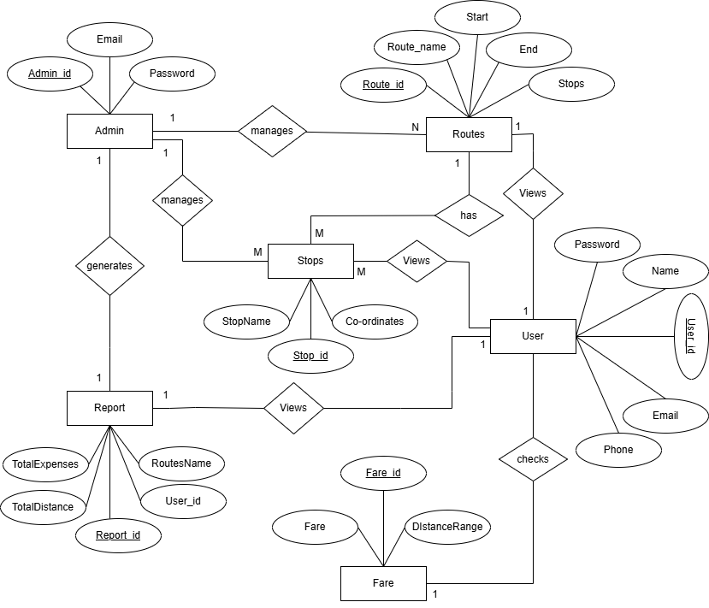

Figure 3.4: Entity Relational Diagram for Public Transportation System

Process Modeling (DFD)
The context diagram and Level 1 Data Flow Diagram (DFD) are crucial components in understanding the flow of data within the Public Transportation System (PTS). These diagrams provide a clear representation of how data is exchanged between the system and external entities like Admins and Users.
In the context diagram, the main inputs to the system include sign-in requests, registration details, and route information requests. The Admin interacts with the system by sending sign-in requests and requesting information about users, routes, and stops. Similarly, the User interacts by registering, logging in, and requesting route information.

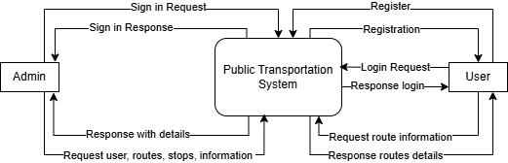

Figure 3.5: level 0 DFD for Public Transportation System
The Level 1 Data Flow Diagram (DFD) for the public transportation system provides a comprehensive overview of the core functionality and data flows within the application.
At the center is the user, who can perform various tasks such as managing their account information, viewing available routes and stops, calculating fares, and accessing travel details. These user-focused processes interact with the user database to store and retrieve the necessary information.
On the administrative side, the diagram shows several key modules that allow the system's administrators to manage different aspects of the application. The "Manage Admin Information" module enables admins to view and update administrative data, including user accounts. The "Manage routes and stops" module gives admins control over the available transportation routes and stops, which are stored in the busroutes and busstops databases.
The "Manage route fare" module allows admins to set and modify the fare pricing for different routes, with the fare details stored in the fare database. Finally, the "Manage Travel Details" module provides admins with reporting and analysis capabilities, drawing data from the traveldata database.
Throughout these processes, there are various data flows between the user/admin functions and the corresponding databases, forming a comprehensive system for managing the public transportation services. The Level 1 DFD illustrates how the different components of the application are integrated and how data is shared between them to support the overall functionality.

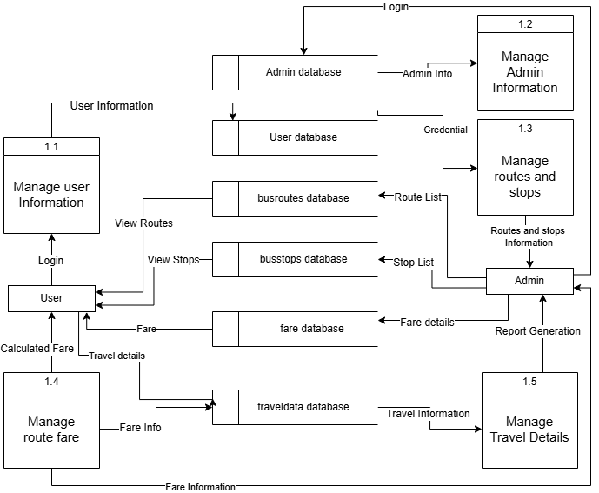

Figure 3.6: Level 1 DFD for Public Transportation System

System Design
To realize the different functional requirement of the system in graphical form, different design diagram of the system has been prepared which are as follows:

Architectural Design
For this system, three tier architecture is used which includes user interface, web server and database. In architectural design, basic structure of the system is shown.
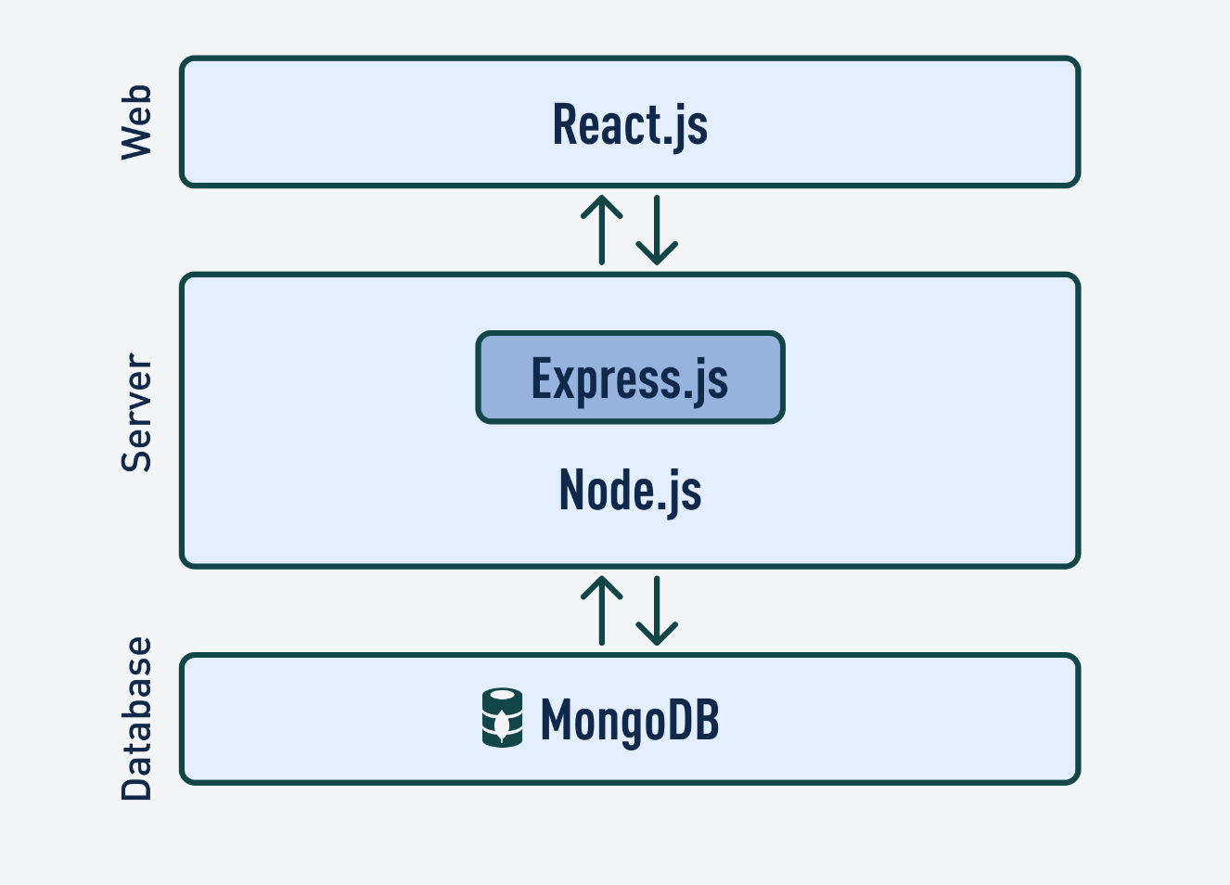
Figure 3.7: Architectural Design of Public Transportation System

3.2.2 System Flowchart
The figure below is the flowchart of Public Transportation System. Here, admin and users login the system and if user is not register then they need to register first. Upon successfully logging in with the correct credentials, the admin is smoothly taken to the Dashboard, a central hub of system insights. If the credentials are invalid or lack proper authorization, the system promptly guides them back to the login page, often with an explanatory message. Within the Dashboard, the admin gains access to a comprehensive overview of the system's vital stats and functions, enabling effortless navigation and management.

Upon logging in with valid credentials, users are seamlessly directed to their personalized Dashboard, where they can access a range of functionalities tailored to their needs. In case of incorrect credentials or unauthorized access attempts, the system redirects them to the login page while providing relevant error messages for clarity. Within their Dashboard, registered users can initiate booking processes and effortlessly track the status of their reservations

For Admin
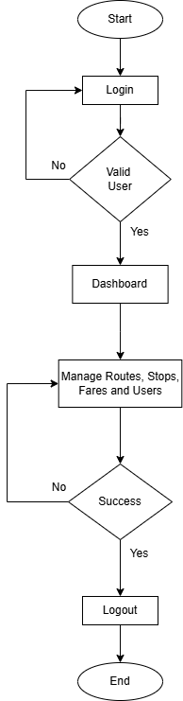

Figure 3.8: Flow chart of Public Transportation System for Admin

For User
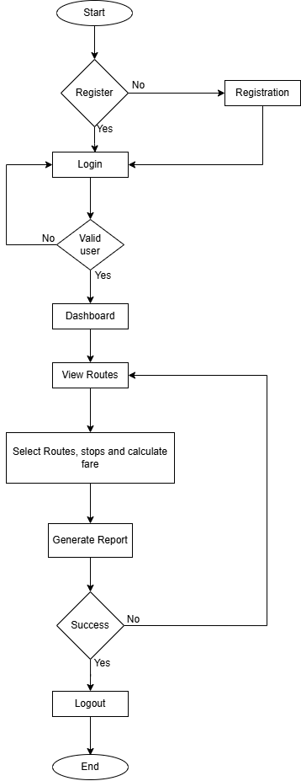

Figure 3.9: Flow chart of Public Transportation System for Users

Interface Design (UI Interface)
Interface design plays a crucial role in shaping the visual appearance of the Public Transportation System, providing users with a preview of its aesthetics and layout. This step ensures that users can visualize how the system will appear before its development commences. The UI design encompasses various key components such as the home page, register page, login page, and dashboard page:

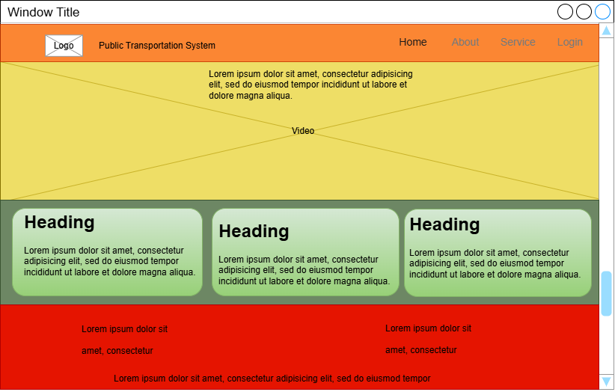
Figure 3.10: UI Home page of Public Transportation System

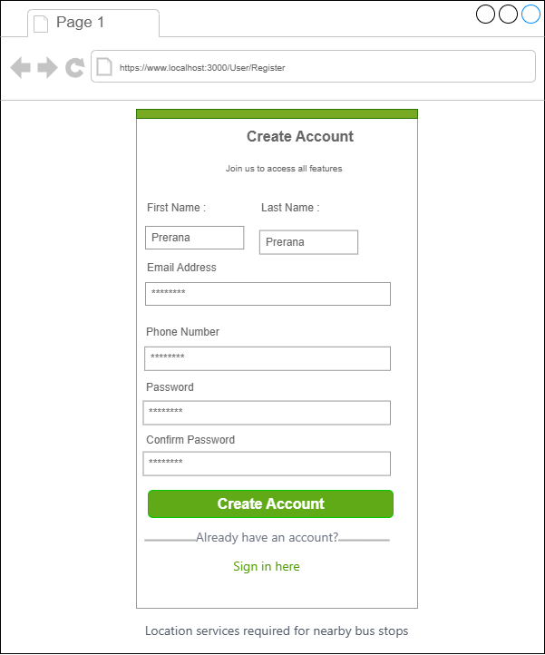
Figure 3.11: Register page of Public Transportation System

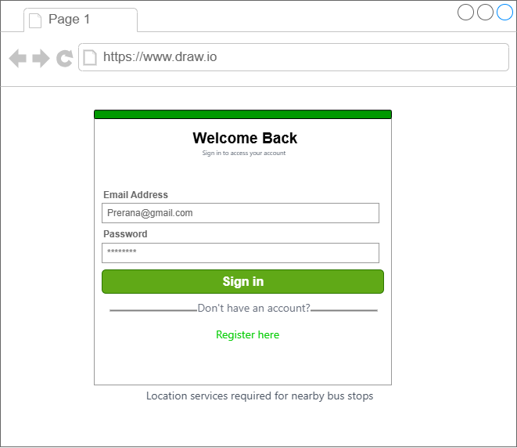
Figure 3.12: Login page of Public Transportation System

3.2.2 Physical DFD

The system is divided into two main components User and Admin. The User can log in to the system (Login process - 1.1). The User can then manage their user information in the User Database. The User can also request route information, which is retrieved from the Busroutes database. The Admin can log in to the system (Login process - 1.1).The Admin can then manage the admin information in the Admin Database. The Admin can also manage the routes and stops in the Busroutes database. The Admin can calculate the fare information and update the Fare Database. The Admin can also manage the travel details and save them in the Travel Database. The Busroutes database acts as a central repository for storing and managing all the information related to bus routes, stops, and fares. Both the User and the Admin interact with this database to retrieve and update the necessary information.
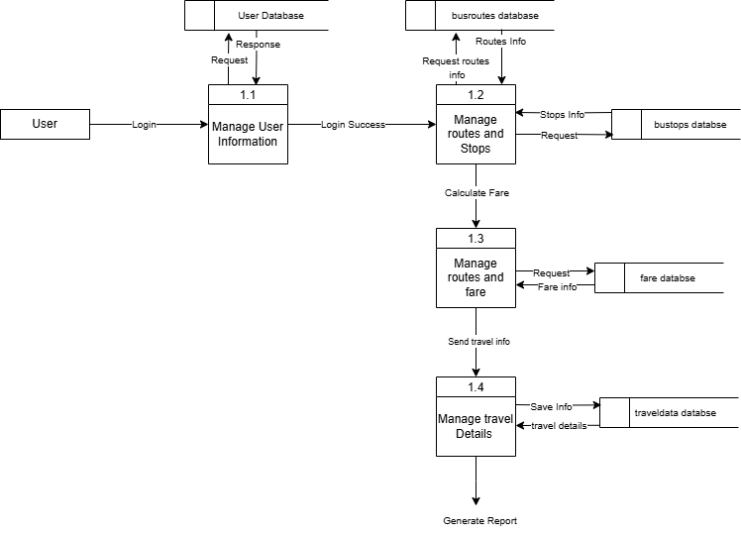

Figure 3.13: Physical DFD of Public Transportation System for Users

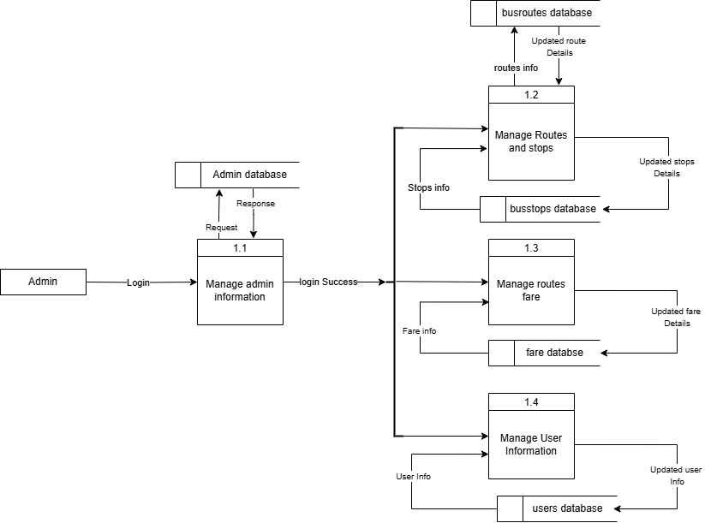

Figure 3.14: Physical DFD of Public Transportation System for Admin

Algorithm analysis
The haversine formula is an equation important in navigation, giving great-circle distances between two points on a sphere from their longitudes and latitudes. It's particularly useful for calculating distances on the Earth's surface, which is approximately a sphere.
Steps of the Algorithm:
- Input Validation: Ensures that all required inputs (e.g., user’s location and route ID) are provided and in the correct format.
- Database Query: Retrieves the details of a specific bus route and its associated stops using a query like BusRoute.findById(id).populate(). This query fetches stops for the route while including related details.
- Data Processing: Filters stops to include only those with valid location data.
- Calculates the distance of each stop from the user’s location using the Haversine formula for geographical distance.
- Formats the data for further processing.
- Sorting: Sorts the stops by their distance from the user’s location using a sorting algorithm (e.g., JavaScript's .sort() function).
- Output: Returns a JSON response containing the nearest stop’s details or an appropriate error message if no stops are found.
Characteristics of the Algorithm:
- Specific Steps: Each step of the algorithm is well-defined and follows a logical flow from input to output.
- Well-Defined Output: Produces a JSON response with the nearest stop's details, including attributes like stop name, coordinates, and distance.
- Finite Termination: The algorithm is guaranteed to terminate. It either successfully finds and returns the nearest stop or provides an error message in case of invalid input or no matching stops.
Performance Analysis:
1. Database Query: The query BusRoute.findById(id).populate() retrieves the route details and associated stops.
- Time Complexity: Best Case (Indexed Database): O(1) for finding the route ID. Populating stops depends on the number of stops on the route, O(n), where n is the number of stops.

  - Worst Case (Poor Indexing): O(m), where m is the total number of stops across all routes in the database.
2. Stop Processing: The .filter() and .map() operations process each stop individually.
- Time Complexity: O(n), where n is the number of stops on the route.
3. Sorting: Stops are sorted by distance using a comparison-based sort (e.g., merge sort or quicksort).
- Time Complexity: O (n log n).
Overall Time Complexity:
- Dominated by sorting: O (n log n).
- In the worst case of poor database indexing: O (m log n).
Space Complexity: Space usage is primarily determined by the storage of stop details in memory during processing.
- Space Complexity: O(n).
Optimizations for Large-Scale Systems:
- Use Spatial Indexing: A spatial index (e.g., R-tree) in the database can reduce query complexity for location-based data.
- Optimize Data Retrieval: Fetch only required fields from the database to reduce query time and memory usage.
- Parallel Processing: Perform distance calculations in parallel for faster processing in large datasets.
This algorithm efficiently identifies the nearest stop for moderately sized routes, balancing simplicity and performance. However, for systems with extensive datasets, implementing spatial indexes and optimizing database queries would be essential for scalability.

CHAPTER 4: IMPLEMENTATION AND TESTING

Implementation

4.1.1 Tools Used

The development of the Public Transportation System (PTS) was enabled through the use of modern tools and technologies, which were selected for their efficiency and compatibility with the MERN stack.
Front-End Tools:
- React.js: Used for building dynamic, responsive user interfaces with fast rendering and state management.
- HTML: Provided the structure for the web pages, including sections, links, and content organization.
- CSS (Tailwind CSS): Utilized for styling and creating responsive, visually appealing designs.
- JavaScript (ES6): Enabled interactivity and dynamic behavior across the system’s UI, enhancing user experience.
Back-End Tools:
- Node.js: The server-side runtime environment responsible for handling requests and managing asynchronous operations.
- Express.js: Simplified the creation of RESTful APIs, handling requests related to routes, schedules, and user data.
Database:
- MongoDB: A NoSQL database used to store flexible, dynamic data such as bus schedules, user profiles, and routes.
- Mongoose: A library to define and manage the data structure within MongoDB, ensuring efficient CRUD operations.
Server:
- Node.js with Express Server: Served as the backbone of the server-side application, handling HTTP requests and interacting with the database.
Documentation Tools:
- MS Office: Used for creating documentation such as system specifications and user manuals.
- Draw.io: Helped in creating system architecture diagrams and flowcharts for better planning and communication.
Development Tools:
- Git and GitHub: Utilized for version control, collaborative development, and tracking changes.
- Postman: Used for testing API endpoints to ensure proper functionality before integration.
- VS Code: The primary code editor, offering debugging and version control features to streamline development.
The MERN stack (MongoDB, Express.js, React.js, and Node.js) formed the core of the Public Transportation System, supported by tools like Tailwind CSS for styling, Postman for API testing, and GitHub for version control. These technologies enabled the creation of a responsive, dynamic, and scalable application that meets the needs of modern urban public transportation systems.

4.1.2 Implementation Details of Modules
The implementation of various modules in the Public Transportation System is carried out meticulously to ensure the system's effectiveness and seamless functionality. The description of the procedures/functions within different modules is outlined as follows:

Admin Module
The Admin Module of the Public Transportation System empowers administrators with comprehensive control and oversight, enabling efficient management and seamless operation of the platform. The following subsections highlight the key functionalities embedded within the Admin Module:
Dashboard: The Dashboard component serves as the administrative control center, displaying essential system metrics, such as the total number of services, new bookings, cancelled bookings, and other vital statistics. This view helps administrators monitor and evaluate the overall performance of the Public Transportation System in real time.
Manage Fare (ManageFare.js): This module allows administrators to manage and update the fare details for different routes in the system. Admins can adjust the fare prices as necessary to ensure that they are up to date with changing operational costs or other factors.

Manage Route (ManageRoutes.js):
Admins are given the ability to add, update, or remove routes in the system. This module ensures that the transportation system remains adaptable, allowing administrators to modify routes based on demand, traffic conditions, or other operational requirements.
Manage stops(ManageStops.js):
This functionality provides admins the tools to manage bus stops, including the ability to add, update, or delete stops as required. It ensures that the list of bus stops is accurate and relevant to the current operational routes.
Manage User (ManageUser.js):
This module gives administrators the ability to view, manage, and delete user accounts. It helps ensure that the system can remove inactive or fraudulent users and maintain a secure environment for legitimate users.
Report (Report.js):
Admins can generate detailed reports on various aspects of the system, such as bookings, services, and operational data. This feature aids in decision-making and performance analysis by providing relevant insights.
Navbar (Navbar.js) and Footer (Footer.js):
These components contain the navigation and footer sections for the admin interface. They allow administrators to quickly access different sections of the system, improving usability and efficiency.
Admin Authentication (adminAuth-router.js, admin-model.js):
Admin authentication is handled through these components, which manage the login and logout functionality for administrators. This ensures secure access to the admin interface and prevents unauthorized users from accessing sensitive data or features.

User Module
Login (Login.js):
The Login component allows registered users to securely log in to the system using their credentials. It serves as the gateway for users to access personalized services and manage their bookings.
Register (Register.js):
This component provides an interface for new users to create an account within the system. It includes fields for basic user information and ensures proper validation to prevent errors during the registration process.
Report (Report.js):
Users can generate personalized reports based on their specific needs, such as route details or fare information. This module enhances user engagement by providing them with the data they require to make informed travel decisions.
Service (Service.js):
This component displays available public transportation services, including information about routes and schedules. It helps users find the most suitable transportation options based on their preferences.
RoutesDetails (Routes-details.js):
Here, users can view detailed information about individual routes, including their nearby stop and fares. This functionality allows users to plan their journeys more efficiently and stay informed about available services.
Header (Header.js) and Footer (Footer.js):
These components provide the navigation and footer sections for the user interface, offering easy access to various features such as login, route information, and service details.
User Authentication (auth-router.js, user-model.js):
This module handles user authentication, allowing users to securely log in and manage their accounts. It ensures that only authorized users can access their personal information and interact with the system.

Database Models and Routes (Backend)
Admin-related models (admin-model.js):
This model handles data management related to the admin section, including storing and retrieving information about admin users, login credentials, and other administrative tasks.
Admin-related routes (admin-router.js, adminReportRouter.js):
These routes define the backend communication pathways for admin requests. They handle operations such as logging in, generating reports, and managing user accounts, ensuring smooth interaction between the front-end admin interface and the backend system.
User-related models (user-model.js):
This model manages user-related data, including user profiles and login credentials. It stores the essential information that allows users to interact with the system.
User-related routes (user-router.js, auth-router.js):
These routes manage user authentication, registration, and access to various system services. They handle requests related to logging in, signing up, and retrieving personalized user data like route information and fares.
Route-related models (busRoute-model.js, busStop-model.js):
These models define the structure of data for bus routes and stops. They ensure that all necessary route and stop information is available for the system to function properly, facilitating tasks like calculating routes, stop schedules, and fare details.
Route-related routes (busRoute-router.js, busStop-routes.js):
These routes handle backend operations related to bus routes and stops. They manage communication between the front-end and the back-end, ensuring that the correct route information, including stops and fares, is accessible to users and administrators.
This detailed structure ensures that all components of the Public Transportation System are well-integrated and functional, providing a seamless experience for both administrators and users.

Testing
During the testing phase, rigorous evaluations were conducted to ensure the accuracy and reliability of the Public Transportation System (PTS). To guarantee the system's effectiveness, the testing process encompassed both unit testing and system testing, targeting individual modules and the overall system performance. The test cases were structured as follows:

Test Cases for Unit Testing
In the unit-testing phase, the modularized components were meticulously examined. A series of test cases were designed to validate the functionality of critical system features, such as user registration and login. Noteworthy test cases include those for user registration and user login:
User Registration:
  - A variety of scenarios was tested, including entering invalid and valid data.
  - The system was expected to handle these cases accurately, displaying appropriate success or failure messages.
User Login:
  - Different input scenarios were tested, including invalid email and password combinations.
  - Successful login scenarios were also validated, confirming the redirection to the user dashboard.
User Registration
S.No. | Test Name | Input | Expected  Output | Actual  Output | Test  Result
1. | Open Application | Public Transportation System | PTS  Register Page | PTS  Register Page | Pass
2. | Enter Invalid full name, email,  Mobile number,  password, confirm password and click register now  button | Full name = Prerana Koirala  E-mail = p2.k@com  Mobil number =9861392884  Password = Prerana@123  Confirm password= Prerana@123 | Invalid email or password. Please try again. | Registration Failed | Pass
3. | Enter Valid full name, email, Mobile number,  password, confirm password and click register now  button | Full name = Prerana  E-mail= PreranaKoirala@gmail.com  Mobil number =9861354899  Password = qwerty1234  Confirm password=qwerty1234 | Registration successful | Registration successful | Pass
Table 4.1: Test case for User Registration of Public Transportation System.

User Login
Table 4.2: Test case for User Login of Public Transportation System.
S.No. | Test Name | Input | Expected Output | Actual Output | Test Result
1. | Open Application | Public Transportation System | PTS  Home Page | PTS  Home Page | Pass
2. | Enter Email and Invalid password | Email: PreranaKoirala@gmail.com  Password:vbjh256 | Invalid details | Login Failed | Pass
3. | Enter Valid email and Password and click login  button | E-mail: PreranaKoirala@gmail.com  Password: qwerty1234 | Login Successful and redirect to view routes | Redirect to view routes | Pass

Test Cases for System Testing
In system testing, whole system is tested as below:

Test Case for Booking Success
Table 4.3: Test Case for nearest route Success of Public Transportation System
Test Case | Successful View of Nearest Stop
Test Data | Nearest stop = Jayabageswori Stop (0.18669 kilometers)  Destination = Swyambhu Stop  Total Fare= Amount: 25 NPR  Distance: 6 kilometers  From: Jayabageswori Stop  To: Swyambhu Stop  Save data = Travel confirmed, and details saved successfully!
Expected Result | Travel confirmed and details saved successfully!
Test Result | Your travel request has been sent successfully!

Test Case for Booking Failure
Table 4.4: Test Case for Calculating fare of Public Transportation System

Test Case | Fare Calculation Failure
Test Data | Nearest stop = Jayabageswori Stop (0.18669 kilometers)  Destination = Swyambhu Stop  Total Fare=  Save data = Please calculate the fare before confirming travel.
Expected Result | A message “Please calculate the fare before confirming travel.” should display
Test Result | A message “Please calculate the fare before confirming travel.” is displayed

Stop add form
Table 4.5: Add stop of Public Transportation System

Test Case | Expected Data | Test Result
On click of add | Adds the new Stop | Successful
On click of manage stop | List the stops | Successful
On click of delete | Delete the stop | Successful

Routes add form
Table 4.6: Routes add form of Public Transportation System

Test Case | Expected Data | Test Result
On click of add | Adds the new route | Successful
On click of manage route | List the route types | Successful
On click of delete | Delete the routes | Successful

Travel Approval
Table 4.7: Travel approval form of Public Transportation System

Test Case | Expected Data | Test Result
On click of save Travel | Successfully add in database | Successful
On click of Report | Show the detailed information of travel | Successful

CHAPTER 5: CONCLUSION AND FUTURE RECOMMENDATIONS

Lesson Learnt / Outcome
The Public Transportation System project has been a great learning experience, helping me develop both technical and soft skills.
Problem-Solving Skills
This project improved my problem-solving skills. I faced several technical challenges and errors, which taught me how to diagnose issues, find their root causes, and implement solutions. These skills will help me approach real-world problems more logically and systematically.
Writing Skills
I also improved my writing and communication skills. Writing technical documentation and proposals helped me articulate my ideas clearly. Using tools like use case diagrams, schema diagrams, and data flow diagrams also helped me present complex concepts more effectively.
Time Management
Time management was crucial for this project. Juggling coding, testing, and documentation taught me how to prioritize tasks and manage deadlines efficiently. This experience will help me better allocate time in future projects.
Teamwork and Collaboration
Although I mostly worked on the project individually, I collaborated with peers during the initial stages and received feedback on the system. This taught me how important collaboration and teamwork are in gathering diverse perspectives and improving the final output.
Adaptability and Learning
I had to learn new tools, technologies, and frameworks throughout the development process, including Node.js, MongoDB, and React. This experience taught me how to quickly adapt to new tools and expand my technical knowledge, which will be valuable in future projects.

Conclusion
The Public Transportation System (PTS) has been successfully developed to achieve its primary objectives, providing a user-friendly platform for individuals to access critical public transportation services. Registered users can effortlessly explore available routes, bus stops, schedules, and fare information, ensuring convenience and accessibility. The system also empowers users with additional functionalities, such as making bookings and viewing specific route details, fostering a comprehensive and tailored experience.

With a focus on intuitive design, the PTS caters to a diverse range of users, enhancing engagement and usability. Transportation data is meticulously structured to ensure clarity, while the platform streamlines operational management and optimizes user interaction.

Overall, the PTS offers an all-encompassing solution that bridges the gap between users and public transportation services, enhancing accessibility, improving user satisfaction, and enabling efficient management of transportation information.

Future Recommendations
Some of the future recommendations for this system are:
• Introduce a digital payment system for seamless and secure ticket purchases.
• Enable offline access to route maps, schedules, and fare details for better accessibility.
• Use AI to suggest personalized routes based on user preferences and traffic conditions.
• Include multi-language support to cater to a diverse user base, including tourists.
• Implement OTP-based authentication for secure login and booking confirmations.
• Add a feedback and rating system to gather user input and improve service quality.
• Display environmental benefits of using public transportation to promote eco-friendly commuting.
• Provide push notifications for route changes, delays, and schedule updates.
• Develop a dedicated mobile app for enhanced user convenience and accessibility.

REFERENCES

[1] | A. Paudyal, S. Shrestha and R. Karki, "Challenges in Urban Transportation in Kathmandu Valley," Nepal Transport Journal, Kathmandu, 2022.
[2] | M. Thapa and P. Dahal, "Infrastructure Limitations in Public Transport Systems of Nepal," Journal of Transport Development, Kathmandu, 2020.
[3] | S. Adhikari, "Urban Growth and Public Transport: Analyzing the Gaps in Kathmandu," International Journal of Urban Studies, Kathmandu, 2021.
[4] | B. R. Gurung, "Environmental Impacts of Fossil Fuel-based Public Transport in Kathmandu," Nepal Journal of Environmental Science, Kathmandu, 2019.
[5] | Asian Development Bank., "Kathmandu Sustainable Urban Transport Project," Asian Development Bank, Manila, 2019.
[6] | R. Singh and A. Manandhar, "Centralized Management for Public Transportation: A Case Study of Kathmandu Valley," Journal of Urban Transport, Kathmandu, 2023.
[7] | S. Lamsal, "he Role of Electric Buses in Sustainable Urban Transport," Renewable Energy Journal of Nepal, Kathmandu, 2020.
[8] | G. Bista, "Policy Frameworks for Green Public Transportation in Nepal," Environmental Policy Review, Kathmandu, 2021.
[9] | R. Mishra, "Lessons from Bus Rapid Transit Systems in South Asia," Asian Transport Journal, New Delhi, 2021.
[10] | S. Pradhan, "Urban Mobility and Infrastructure Development in Kathmandu Valley," Nepal Infrastructure Journal, Kathmandu, 2020.
[11] | R. Subedi, "Challenges in Implementing the Kathmandu Sustainable Urban Transport Project," Urban Planning Review, Kathmandu, 2021.
[12] | D. Sharma, "Integration of GPS Tracking in Urban Transport Systems," Nepal Tech Review, Kathmandu, 2022.

APPENDIX I

Database overviews

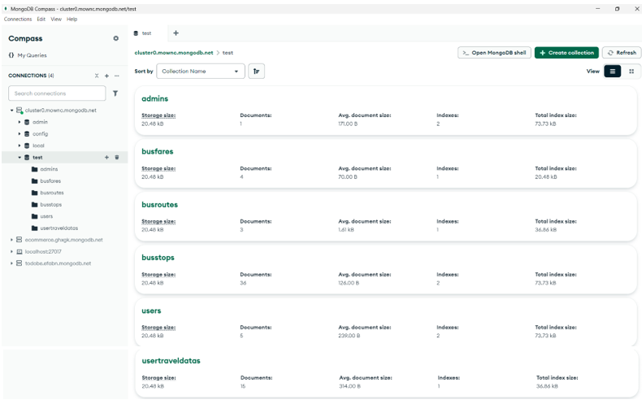
Frontend Overview
- Home Page
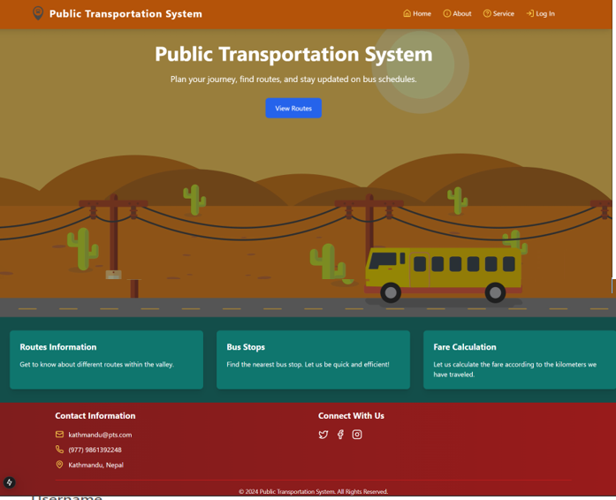

- Login page for admin
`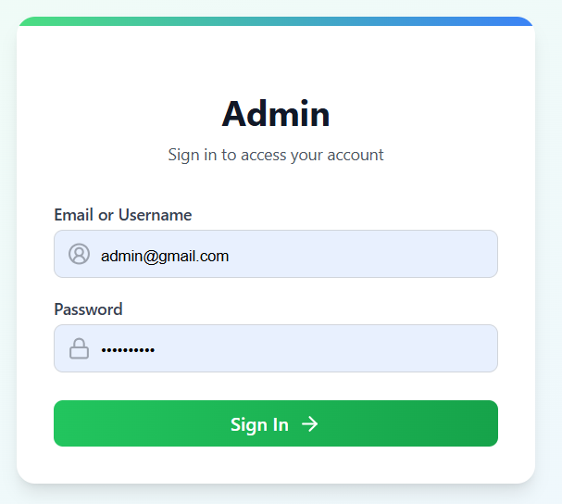

- Service Page
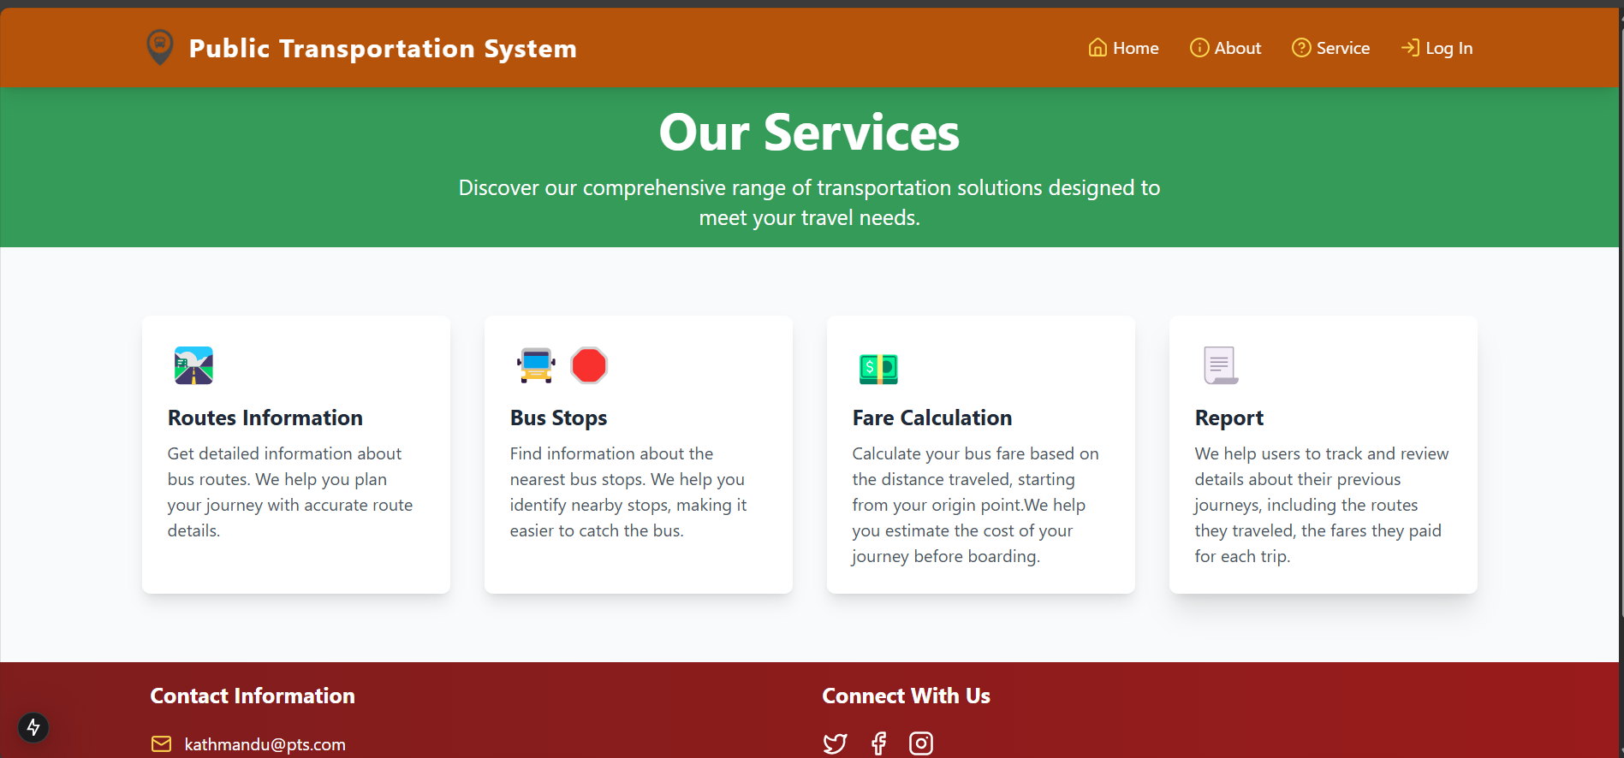

- About us page
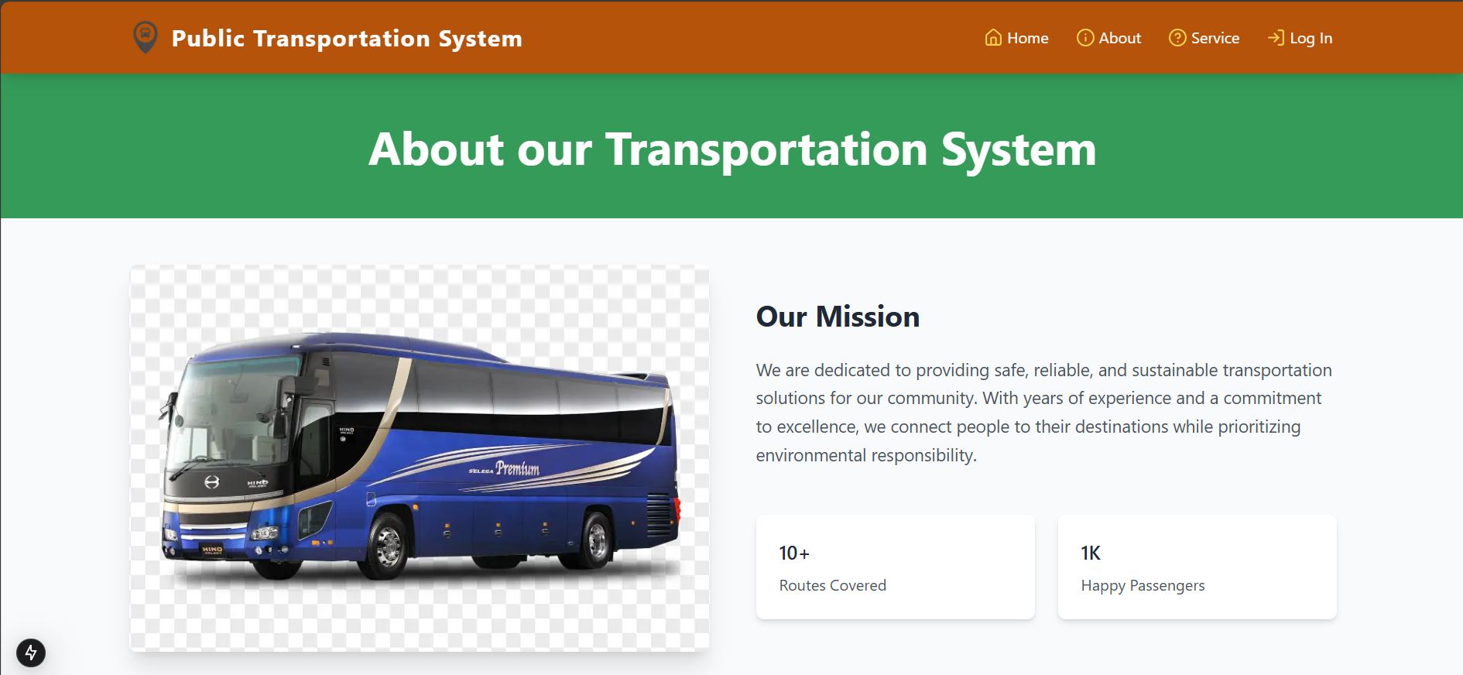

- User Login page
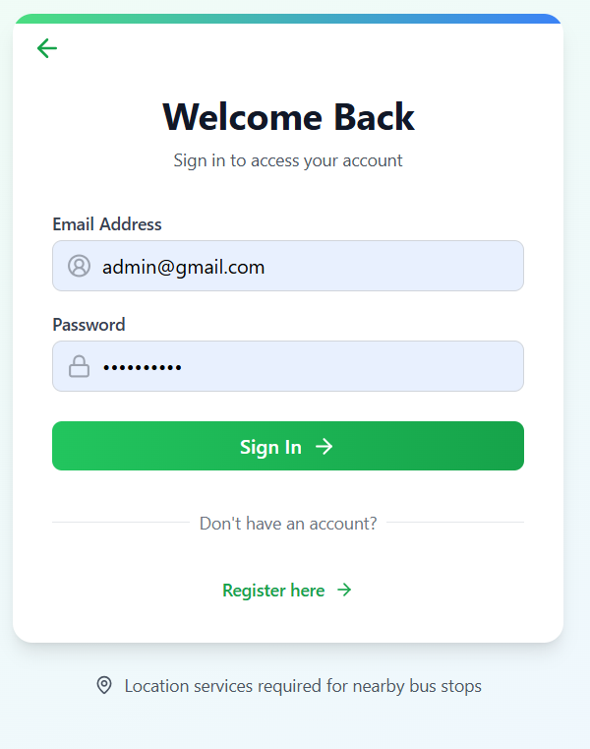

- View Routes page
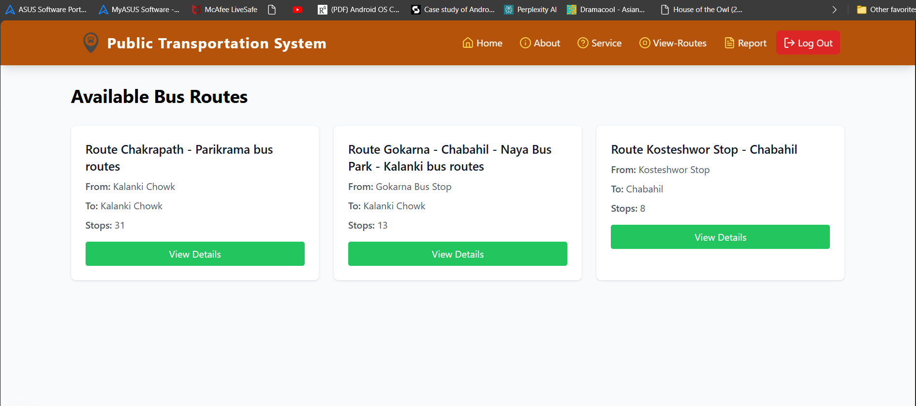

- Routes Details page
